MED 683 Name____________________________________
Exeter Math problems
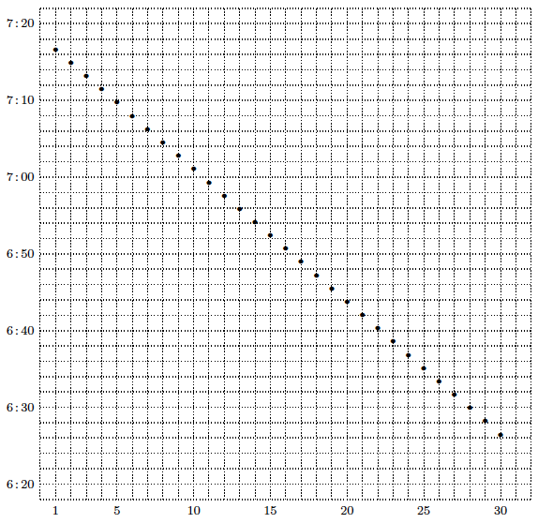

The graph displays the time of sunset at Exeter during September. Some questions:
- At what time did the sun set on the 5th of September? on the 30th of September?

- On what day does the sun set at 6:54? at 7:08? at 6:30?

- Guess the time of sunset on the 1st of October and on the 31st of August.

- What is the average daily change of sunset time during the month of September?

- The dots in the graph form a pattern. Jess thinks that this pattern continues into October, November, and December. What do you think? Make a graph that shows how the time of sunset at Exeter changes during an entire year. A good source for such data is the U.S. Naval Observatory site http://aa.usno.navy.mil.

- What happens on the Autumnal Equinox, which is the 22nd of September? Guess what time the sun rises on this day.
2. It is sometimes necessary to write fractions with variables in the denominator. Without using your calculator, rewrite each of the following as a single fraction. This is called combining over a common denominator.

3. Find a way to show that points A = (−4,−1), B = (4, 3), and C = (8, 5) are collinear.

4. It takes one minute to fill a four-gallon container at the Exeter spring. How long does it take to fill a six-gallon container? Fill in the missing entries in the table below, and plot the corresponding points on the grid.

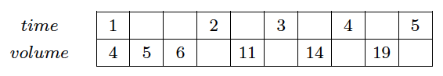

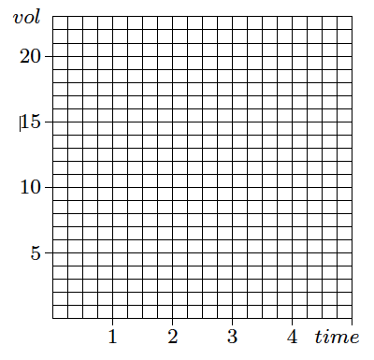

Notice that it makes sense to connect the dots you plotted (thereby forming a continuous pattern). Is
the same true of the sunset-time graph you looked at recently? Explain.

5. I have been observing the motion of a bug that is crawling on my graph paper. When I started watching, it was at the point (1, 2). Ten seconds later it was at (3, 5). Another ten seconds later it was at (5, 8). After another ten seconds it was at (7, 11).
(a) Draw a picture that illustrates what is happening.

(b) Write a description of any pattern that you notice. What assumptions are you making?

(c) Where was the bug 25 seconds after I started watching it?

(d) Where was the bug 26 seconds after I started watching it?

6. A bug moves linearly with constant speed across my graph paper. I first notice the bug when it is at
(3, 4). It reaches (9, 8) after two seconds and (15, 12) after four seconds.

(a) Predict the position of the bug after six seconds; after nine seconds; after t seconds.
(b) Is there a time when the bug is equidistant from the x- and y-axes? If so, where is it?

7. The x- and y-coordinates of a point are given by the equations shown below. The position of the point depends on the value assigned to t. Use your graph paper to plot points corresponding to the values t = −4, −3, −2, −1, 0, 1, 2, 3, and 4. Do you recognize any patterns? Describe them.
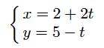

8. Crossing a long stretch of the Canadian plains, passenger trains maintain a steady speed of 80 mph. At that speed, what distance is covered in half an hour? How much time is needed to cover 200 miles? Fill in the missing entries in the table below, and plot the corresponding points on the grid.

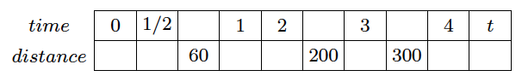

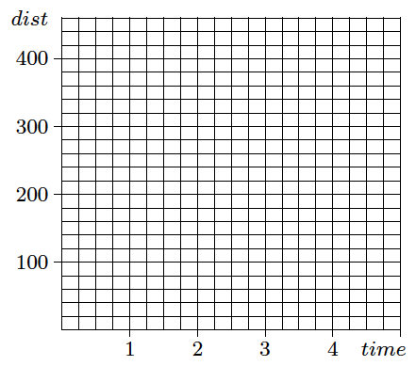
9. The problems about the Exeter spring and the Canadian plains contain relationships that are called proportional relationships. In your own words, describe what it means for one quantity to vary proportionally with another. Which of the following describe proportional relationships?
(a) The gallons of water in a tub and the number of minutes since the tap was opened.
(b) The height of a ball and the number of seconds since it was thrown.
(c) The length of a side of a square and the perimeter of the square.
(d) The length of a side of a square and the area of the square.

(continued) Sketch graphs for each of the situations described above. Be sure to include meaningful descriptions and scales for each axis.

10. A line goes through the points (2, 5) and (6,−1). Let P be the point on this line that is closest to the origin. Calculate the coordinates of P.

