MAT 161 Section 1.4

**Definition** Let  be a function. A new function, , called the *derivative* of , is defined as follows: *the instantaneous rate of change of at *

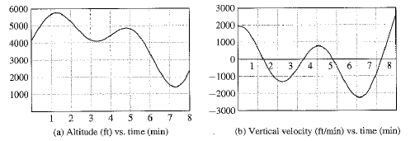Terminology: We refer to as the *original* function or the *amount* *function* and as the *rate function* or *derivative*. We’ve seen this previously in section 1.1 as we looked at A(t), the altitude or position of the balloon and V(t), the vertical velocity or rate-of-change in altitude for the hot air balloons shown below.

Problem #1:

At 12:00 noon, a New York State Trooper patrol car enters NYS Thruway (I-90) at Syracuse and travels for several hours– sometimes heading east and sometimes heading west.

Functions and derivatives allow us to describe this context in detail. Let’s define the following to begin:

*t*: the time measured in hours since noon

*P(t):* The position of the car at time *t* measured in miles to the east of Syracuse

*V(t):* The eastward velocity of the car at time *t* measured in miles per hour

The graphs below the car’s position and velocity functions.

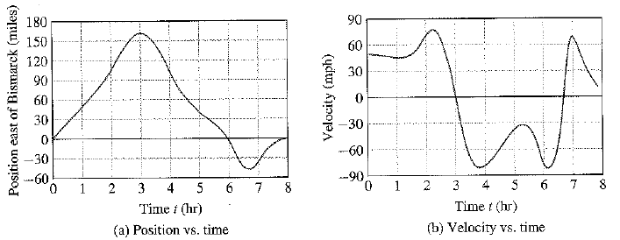

1. Describe what P(2) and V(2) represent and state their values.
2. What are the values of P(6.5) and V(6.5) and what do they mean in this context?
3. In general:
   1. P(t) > 0 means that __________________________________________________________
   2. P(t) < 0 means that _________________________________________________________
   3. V(t) > 0 means that _________________________________________________________
   4. V(t) < 0 means that _________________________________________________________
4. What are the roots of V(t)? What is happening when V(t)=0 and how is this shown on the P(t) graph?
5. Consider the interval 3 ≤ t ≤ 6.7? Describe what is happening during this time and how each graph shows what is happening.
6. Consider the velocity of the car at t=1 and t=2. What can you say about how the velocity is changing at those times? That is, if you were in the car what would be experiencing?
7. Was there ever a time where the *acceleration* of the car was 0?

1. On the graphs below, draw the position and velocity of a car that starts at Syracuse and travels east at a steady 60 miles per hour for 3 hours and then turns around (does an illegal U-turn) and drives steadily westward at 60 miles per hour for 4 more hours before stopping.

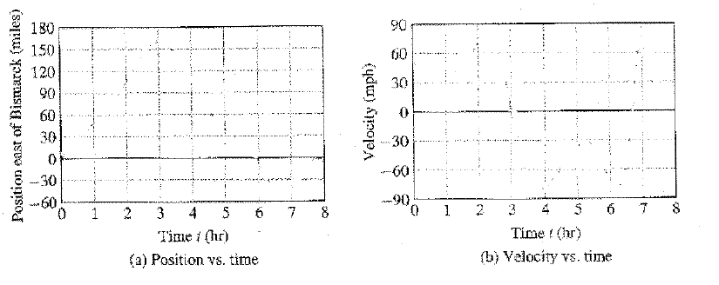

1. (continuation) How would you describe the velocity? Is this something that you could predict from the position graph?

Problem #2.

Definition: Let  be a function. A new function, , called the *derivative* of , is defined as follows: *the slope of the -graph at *

Example 2 from section 1-4:

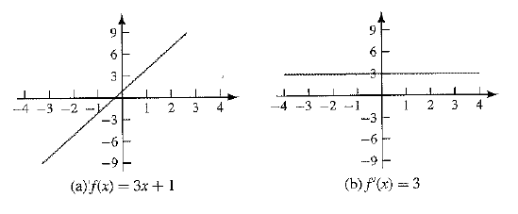

1. Use the graph the function  below to estimate the value of , , and .

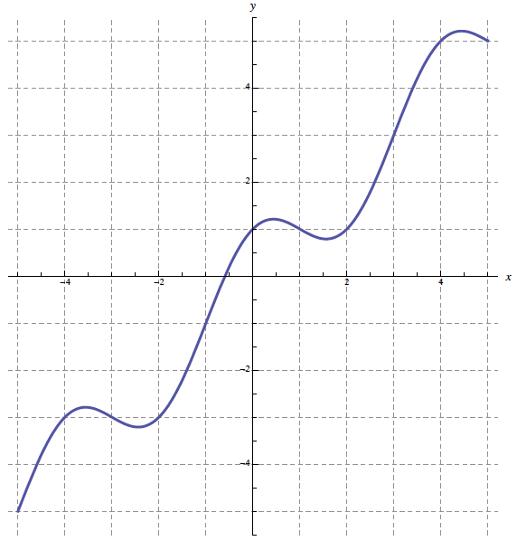

1. Write the equation of the tangent line to at x=–3.