MAT 161 Names:________________________________________________________________________

Section 1.2 problems

1. Match each of the graphs below with the corresponding transformation of the given function.

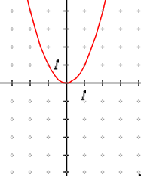 

i.  __________ ii.  __________

iii.  __________ iv.  __________

v.  __________ vi.  __________

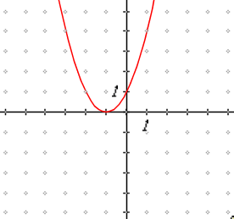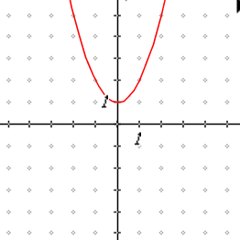A. B. C.

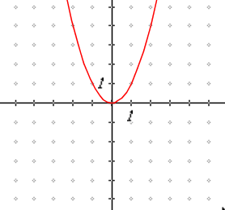

D. E. F.

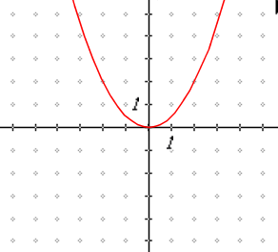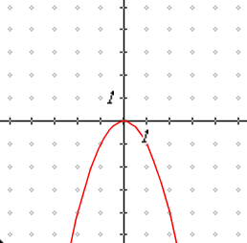

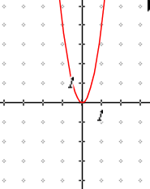

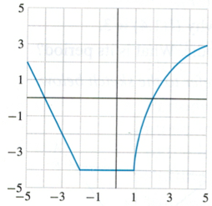

1. The graph of the function  is shown to the right.

Sketch the transformation of  given by each function  below.

A. 



B.  C. 

D.  E. 



1. Use the graph of h(x) below to respond to A – E.

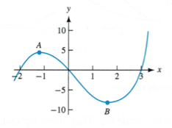

1. Identify the roots of h(x).
2. For 1≤x≤3, is h(x) concave up or concave down?
3. Identify an interval where h(x) is decreasing.
4. Identify a local maximum and local minimum.
5. Mark the location of the inflection point on the graph by labeling the point C.
6. For which value(s) of x does the rate of change of h(x) appear to be the greatest?