MAT 161

Problem 1.

Hot days on the Kansas prairie generate strong updrafts and downdrafts. In the gondola of a hot air balloon two instruments were used to collect data displayed in the graphs below. An altimeter recorded the balloon’s altitude in feet (shown in graph A) and a rate-of-climb meter recorded how fast the balloon rose and fell (i.e., its vertical velocity) over the 8 minute ride (shown in graph B).

(A) (B)

1. 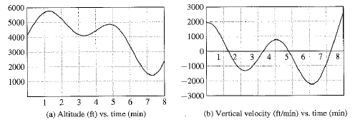What was the approximate altitude 2 minutes into the ride?
2. Was the balloon rising or falling on the interval 5≤t≤7?
3. Describe the motion of the balloon in terms of altitude on the interval 2≤t≤4.

We say Altitude is a function of time and write A(t) which tells us that the value of A depends on the value of t. Similarly, Vertical Velocity is a function of time and we write V(t) to represent that.

1. Using the above notation, what does A(2) represent?
2. Notice that the velocity graph has negative and positive values for the velocity of the balloon. What does it mean when V(t) > 0?
3. What is the sign of V(t) on the interval 5≤t≤7? Does this have any relationship to the response you wrote in ii.?
4. What is the sign of V(t) on the interval 0≤t≤1? Is this related to the altitude of the balloon between t=0 and t=1?
5. Find the approximate times when the vertical velocity of the balloon is 0. What does this tell you about the balloon’s motion?
6. (continuation) What do you notice about the altitude of the balloon when

V(t) = 0?

1. What is V(6)? What does this tell us about the balloon’s motion? How would people riding in the balloon feel at this time?

1. (continuation) Now look at the altitude graph around t=6. Is there a way to verify that the answer to x. is correct by using this graph to estimate the vertical velocity?

Problem 2. State in your own words what we mean by a ***function*** in mathematics.

Problem 3. Are the following examples of functions?

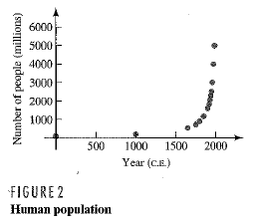







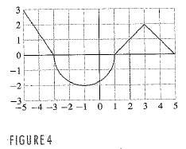

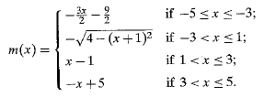(continuation) The graph in iii. can be represented algebraically by the *piecewise* defined formula below:

Find m(-2)

Problem 4. Given the function , let’s define  to be the distance from the originto any point  on the graph of .

1. Graph  below.
2. Find . Find the distance from to .
3. 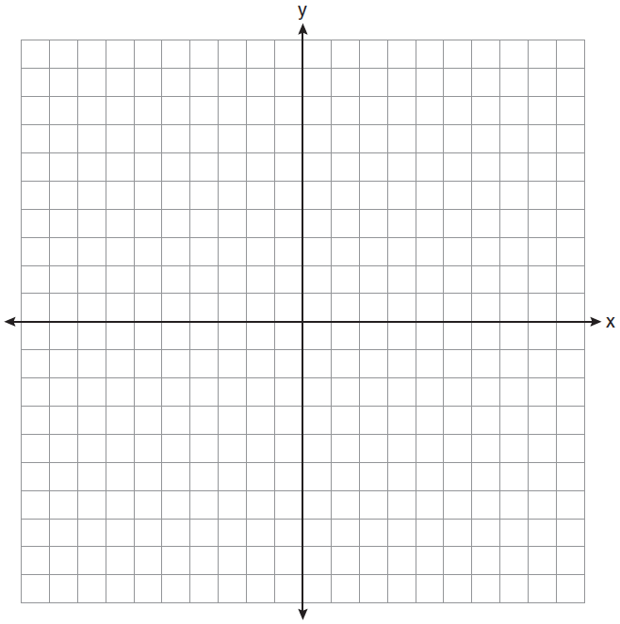Choose another point on  and find the distance between (0,0) and that point.
4. What is the distance from (0,0) to any point (x,y) that is on ?